

Project: Voedselbankactiviteiten verbeteren

First project: HBO – FONTYS PRO



[Datum]

Inhoudsopgave

Project: Voedselbankactiviteiten verbeteren 0

Intro 2

Knowledge pre-start: 2

Coding: 2

Hardware: 2

Security: 2

Data analysis: 2

Basic IT, Cloud & Networking: 2

Project planning: 2

Analsys 2

Primary analysis: 2

Food donations and management: 2

Food waste 3

Coordination 3

Scalability 3

Advice 3

Food donations and management: 3

Food waste 3

Coordination 3

Ease of access: 3

Scalability: 4

General setup: 4

Menu layout: 4

Landing page: 5

Login 5

Account 6

General information 6

Locations 7

Frequently asked questions 7

Affiliates 8

Connected soup kitchens 8

Eligibility Check 9

Sign up 9

Servers & Networking: 9

Questions 9

Topologie 10

Setup: 10

Database: 11

Questions 11

MySQL: 11

Coding 12

PHP: 12

HTML: 12

Css: 12

JS/Jquery: 12

Python: 12

## Intro

I am going to write this project in English, because we are going to work under the assumption that the majority of knowledge shared in the field of IT and technology in general is done in English. We should also not skip the idea that we can simulate the situation of a multi-national company.`

## Knowledge pre-start:

#### Coding:

CSS, MySQL, PHP, Jquery. Javascript, HTML,   
I currently have no payed host, but the only online project available is:  
Code: [GitHub - R3dpriest/SWI-Calculator: Very Basic staion calculator for x4 - SWI mod.](https://github.com/R3dpriest/SWI-Calculator)  
Online: [SWI - Station calculator V2.01](https://r3dpriest.github.io/SWI-Calculator/SWI-Stationcalculator.html)  
With the limitations of github I decided to build my database in JavaScript arrays. Work with the tools available. I have previously build a rudimentary CMS, but I lost access to my backup without my knowledge and had a hard drive crash. Thus lost my project.   
I have worked on the service desk of a software company called IXsolution.

#### Hardware:

I worked for 1,5 year in a computer build/repair shop in Tilburg named Computaria. I did some basic hardware analysis and building. Thus VERY limited when it comes to the hands on hardware repair, but I can play the hardware Lego’s with ease.

#### Security:

Very limited. In my current job I do spam analysis, manage apps in intune, review help secure AVG guidelines. My technical knowledge is bare bone.

#### Data analysis:

I find this one hard to judge.

#### Basic IT, Cloud & Networking:

I am currently in a helpdesk level job, but with a decent level of sys-admin rights. I currently have **useradmin** rights in the Entra environment. I am currently employed at Baanbrekers. So far when I asked for additional rights for projects I have been given them. This all predates my degree.

## Project planning:

### Analsys

#### Primary analysis:

The food bank is a NGO that functions based on donations and runs for a large part on voluntary work. The organization can function on a local county based level, but if considering the food bank is a national based organization we can assume that it can be scaled up to a national level if the local foodbank trail is a success.

#### Food donations and management:

The request is to streamline food donations so that donations, this is in order to reduce waste and reduce effort and increase interconnectivity between different food banks.   
  
There is also the request to centralize and streamline the donations. This involves an easy way to pledge and keep track of donations and a centralized financial donation page that deals with banks without a lot of additional steps

#### Food waste

The foodbank would also like to have the ability to minimize food waste.   
If you want to minimize waste you must have a good inventory management, and abilities to distribute things the goods without wasting materials.

#### Coordination

There is a clear question regarding to coordination. The request asks for an ability to coordinate food donations with the eye on food waste and to coordinate volunteers in order to make sure that communication (s.a. calling in sick) is easy to do.

#### Scalability

There is an indirect benefit to Scalability in these sense that they have a request to reduce food waste and to benefit the management of volunteers. If this solution runs for multiple food banks there could be an exchange of volunteers and donations if there is a surplus in the local area.

### Advice

#### Food donations and management:

* Create an easy way to donate food. The solution to this can be cone by having an PDF parser and running into to an SQL database of ingredients. This should lower the barrier of entry in terms of complexity.
* Create a centralized place for financial donations. (integration of IDEAL)
* Create the ability to have an internal message system (possibly linked to a mail server in order to send notifications when a message is received.)

#### Food waste

* Food waste reduction can be achieved by holding the entire stock in an inventory (SQL)
* Create a database with healthy and easy recipes (MongoDB)
* Create the ability to request or offer inventory another foodbank.
* Create the ability

#### Coordination

* The ability to create rosters
* The ability to manage volunteers
* The ability for volunteers to call in sick
* The ability to integrate multiple branches of the food bank in a central system.

#### Ease of access:

* SAAS solutions offer ease of access to both volunteers and donors. It does not need anyone to download and/or install additional software.

#### Scalability:

* Web based applications can be easily be scaled without needing additional security levels. Without needing additional server parks.
* Other types of applications CAN scale in terms, but web based applications have the advantage that it does not need additional licenses or hardware.
* Hosting all the hardware on sight (with a back-up on a secondary site) gives the ability to scale up the resources required with ease. This should
* Creating a CMS with the ability to alter settings.

### General setup:

#### Menu layout:

1. Create account / Log in(depending if logged in)

* If logged in

1. Account

* Always visible

1. General information
2. Locations
3. Frequently asked questions
4. Affeliates

* Donor pages

1. Connected soup kitchens (gives contact information of the soup kitchen in the area)
2. Make a pledge

* Client pages

1. Eligibility check
2. Sign up

* Member

1. Inventory
2. Pledges

* Admin

1. Client lists
2. Applications

* System & local admin

1. Accounts
2. Locations
3. Server status
4. CMS

#### Landing page:

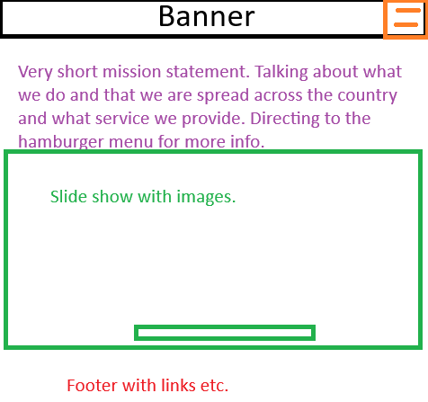

#### Login

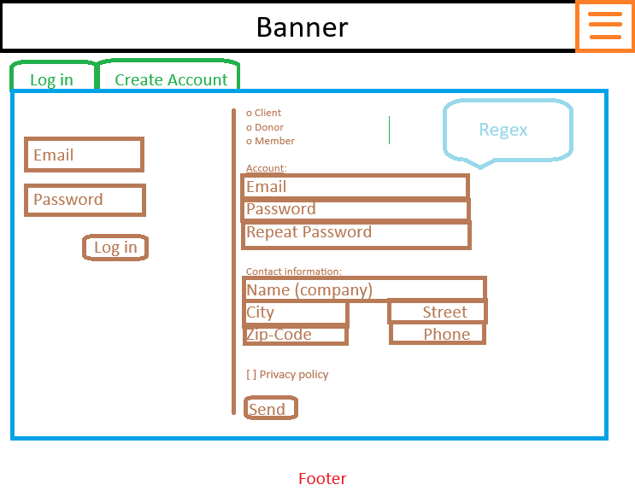

#### Account

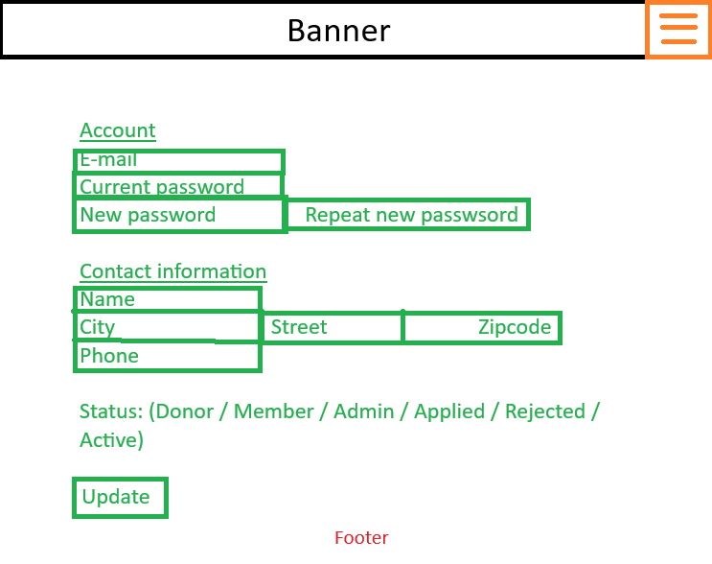

#### General information

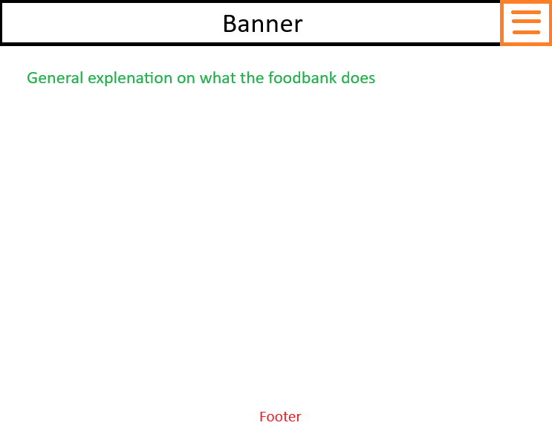

#### Locations

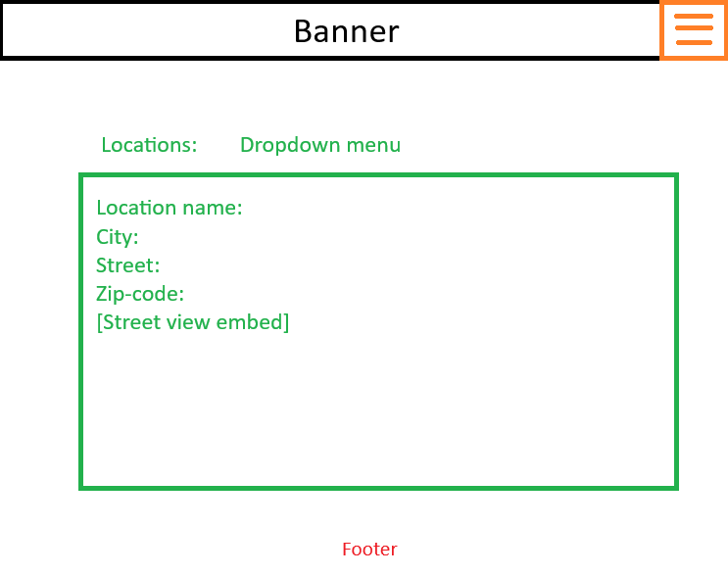

#### Frequently asked questions

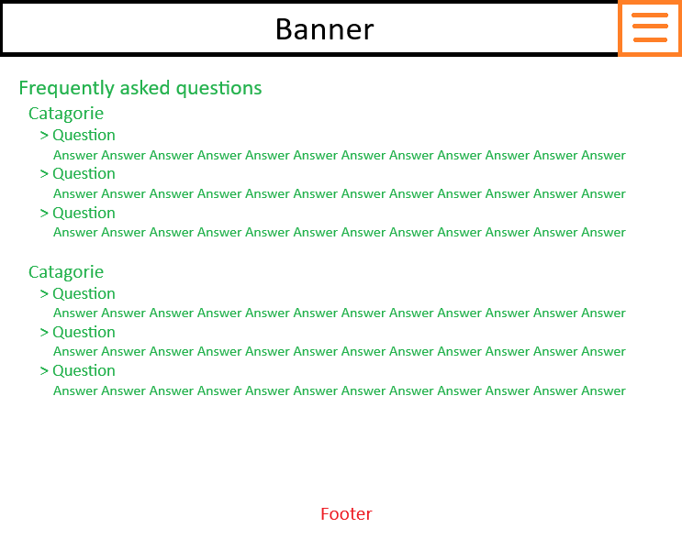

#### Affiliates

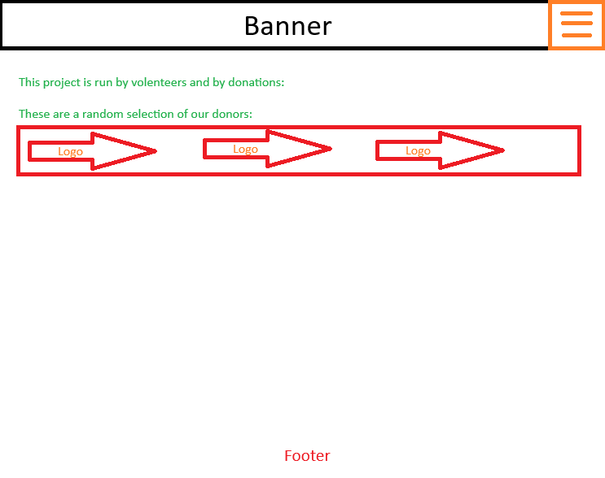

#### Connected soup kitchens

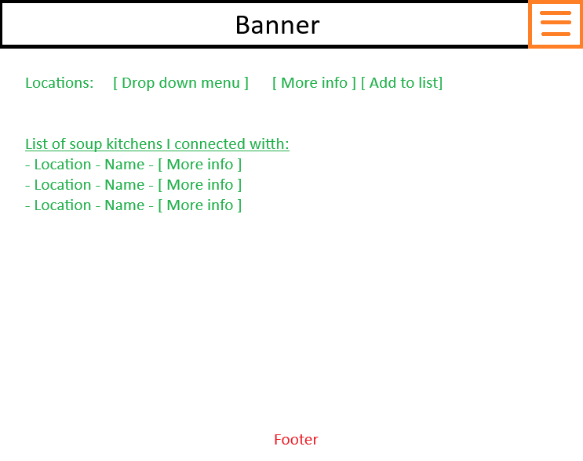

#### Eligibility Check

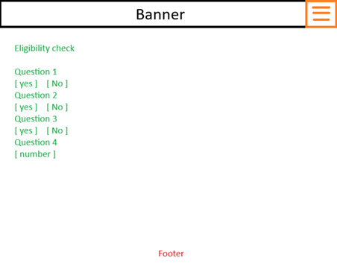

#### Sign up

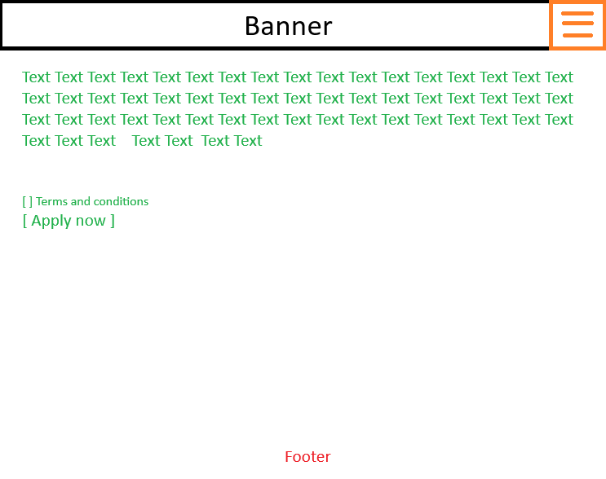

### Servers & Networking:

#### Questions

**Question:** What is SSH.  
**Answer:** SSH is secure shell and is a protocol encrypts, lets you transfer and lets you administrate securely from an insecure network environment. **Question:** What are the ports used for frequently used webhost protocols.  
**Answer:** list  
  
**Question:** What are exactly are STARTTLS and SSL and what would differentiate the two.  
**Answer:**

**-** STARTTLS is the command to upgrade an unsecure connection to a secure connection using the TLS protocol. The client connects over a plain text port (SMTP 587, IMAP 143) then uses that command to start the protocol. [Flexible and widely supported and easier to implement]

- SSL/TLS is secured from the get-go. The client connects to a non-plain text port that expects encryption from the start. (SMTP 465, IMAP 993) [Simpler in terms of protocols, preferred in a secure setup]

#### Topologie

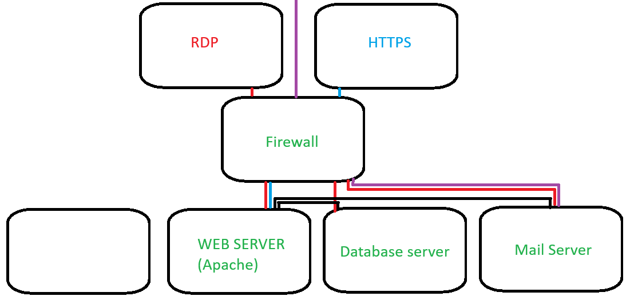

#### Setup:

##### Firewall:

- Block all traffic towards the database server, with exception of RDP of admins. (port 3389)  
- Block all traffic towards the webhost with the exception of http(s) (port 80, 443) and RDP from admin’s ip (port 3389)  
- Allow communication on port 3306 between webhost and database.  
- Allow communication away and to port 587 to the ip from the mail server.  
- Allow communication with whatever server runs updates. (obviously managed)

##### Mail server:

- Allow inbound communication for the SMTP (port 587) [STMP / STARTTLS]

##### Webhost:

- Allow inbound http(s) (port 80, 443)  
- Allow outbound communication with DB specifically to database server (port 3306)  
- Allow RDP to admin Up’s or internal network (port 3389)  
- Allow outbound to the mail server. (port 587 / 465)  
- Deny all other traffic

##### Database:

- Allow communication from internal network ip-range RPD sessions (port: 3389)  
- Allow communications from the webhost running Apache (port: 3306)  
- Deny all other traffic.

### Database:

#### Questions

**Question:** What are the main differences between SQL and Non-SQL databases.  
**Answer:** SQL databases are structured, easy to manage and very reliable. Data is pre-layed out in tables and sheets. Non-SQL databases are less structured and are way more flexible.   
  
**Note:** With the answer of the previous query I came to the conclusion that things like recepies might be easier to manage in a non-SQL database. You do not know the ingredients and number of ingredients beforehand.  
**Question:** Does a hybrid functionality exist?  
**Answer:** Yes you can create hybrid setups with MYSQL and MongoDB.  
  
**Question**: Can the data be freely interchanged or interwoven?   
**Note**: As I started seeing the answer it connected and is obvious. You use a third party script in most cases to initiate and structure questies.  
**Answer**: Yes, *gives example using MongoDB, Mysql, Php

#### MySQL:

Create_database.sql

MongoDB**:**

Set up a database with recipes. I am not familiar yet how these dynamic databases work, but I figure either the Recepies are requested from the database or placed into the database.   
  
ID: 1  
Name: Tomato soup  
Ingredient: Tomatoes  
Ingredient: Water  
Ingredient: Minced meat  
Ing… etc.  
Instruction: Start with boiling water,   
  
The employee uses an AI script that lists the available ingredients and number of clients to the food kitchen. The script queries the database and or the internet. Spits out a result and perhaps places that data in a temporairy storage. Upon accepting the list the database is updated with a “Outgoing order” the outgoing order

### Coding

#### PHP:

Dynamic page generation, database interface, backend scripts

#### HTML:

Should be generated from PHP. Should use as little hardcoded as possible.

#### Css:

A simple and calm UI. Nothing fancy

#### JS/Jquery:

Possible create a simple slide show application. Create a few interactions between web page and PHP (database) using ajax.

#### Python:

According to co-pilot this is the best solution to send an AI over database records to create menu with recepies.

**Scripts**:   
1. Display the stock per product or per resource type. Show a 10 week median.   
2. Derive the week system based on a datatime (PHP)  
3. Create a UI that shows you inventory, history   
4. Create a robust login system, if at all possible WITH two factor authentication.  
5. Create a Location based inventory display system alongside roles. (user, local and system admin)  
6. Bare code reader => linked to products  
7. Possibly visualize with Power BI raport  
8. Create a script that deals expiring dates. The script must go off the assumption that the oldest materials are used.  
.